**Create DB2 cloud instance on IBM Cloud**

<https://console.bluemix.net/dashboard/apps>

Select "Create Resource"

Select "Databases"

Select "Db2"

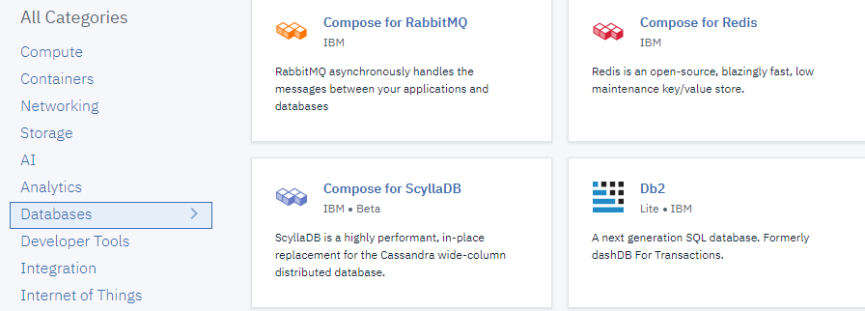

Choose service name and fill other details

Create service

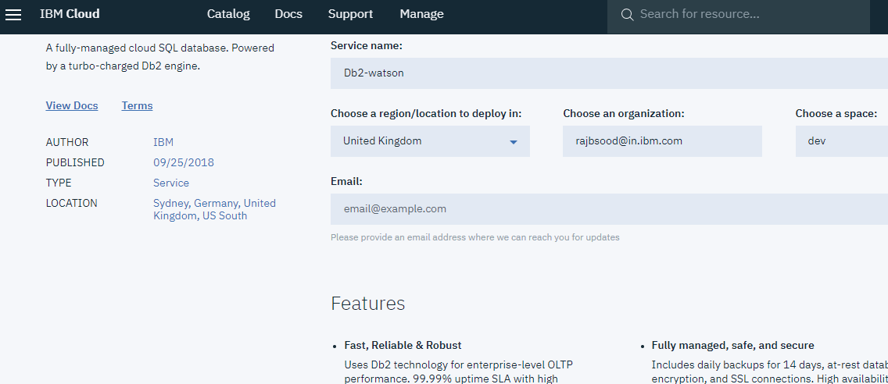

**Go to dashboard**